**Lesson 17:-**

In this lesson we will learn about **Landing page**



This is the word that if you listen again and again so we should tell you what it is Many times our purpose of doing SEO is very specific. It can be a short term goal. We just want that if anyone come I our website then he should come in Anfroid App development sourse course

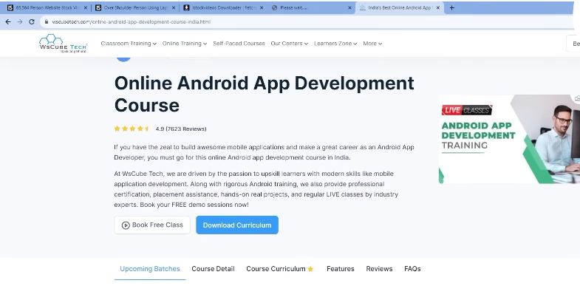

And land there Now landing page we mean that particular page that is specifically designed for a particular market campaign. For example Teacher want there should be more digital marketing related enrolment then Teacher will target that page where digital marketing is stored and we will optimise it and we would want that it should rank so when some one will search that digital market course online

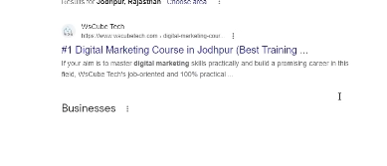

Then that particular page is shown as below

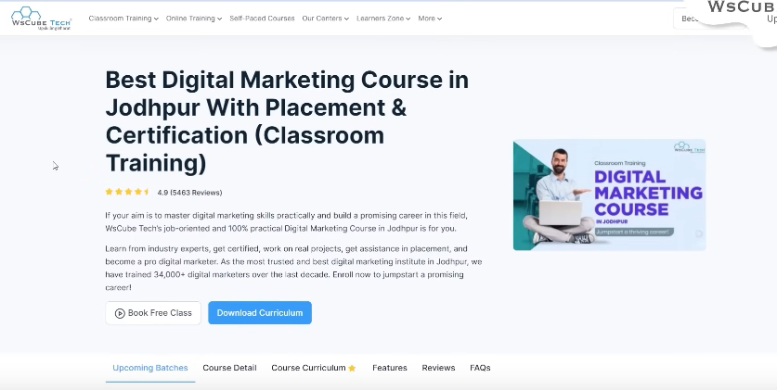

We want that above page to be ranked People click there and get converted

By landing page we mean that whatever page is ranking or the page you want ot be ranked would be our landing page but there come context is changed that you are running a marketing campaign Now you want that people should come nad get converted mean they become our customer or client . They call us and give us leads. If there is some specific page and you are targeting it

If we talk about teacher website that is WS Cube Tech in which there are many landing pages

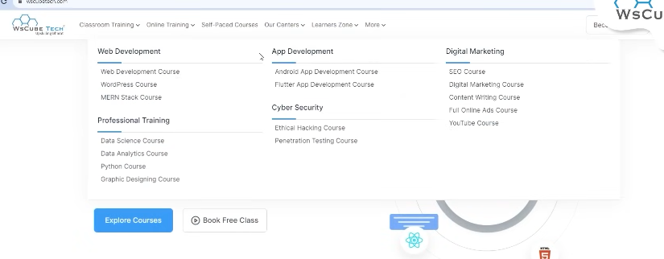

For example if you want to do android development course then for that a different page is made where that course has all the information and we have targeted that whenever someone will search Anroid development course online or a keyword similar to it then this page will be ranked



Similarly we have done for **cyber security**



**Digital Marketing**



**Web development Course**

And so on

So these are our different landing pages that we want to be ranked on different keywords Similarly if you do paid campaign



Like you run Google ad campaign then in that case you decide landing page that following by this ad where they will land

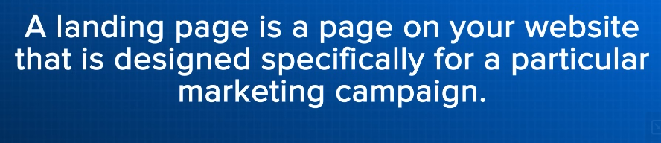

So it is nothing just a particular web page in the website that is designed for a particular marketing campaign or for getting lead for particular services So we call this page a landing page where our potential customer, user will land

**Lesson 18:-**

In this lesson we will learn about **Exit page**

Whatever vocabulary is being shared we will hear it again and again and also see it again

Now exit page mean when a person enters in our website. It can happen that he enters in our page and exit it from there . It can happen he go to one page and then to second and then to third and then exit from there . So the page that was used more in exiting by a person we call it exit page

So exit page is that page that user used to exit from our website. Every page has its exit rate

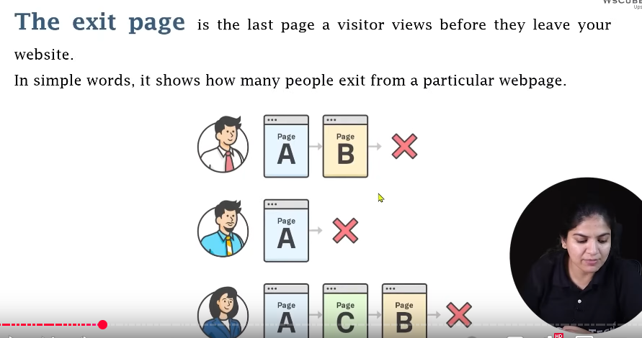

For example a person comae and then he go to page A and then to Page B and then exit from here

Then another user enters page A and then exit

Now another user comes who go to A and then to C and then to B and then exit

If we analyse all of these sessions then B page is used mostly to exit

So most exit rate would be of B page and we come to the conclusion that this page has fault due to which people using page for exiting is page B So B has more exit rate

So tha page who has high exit rate has less chances to rank it is not like that there are 0 chances yes you have to do work hard there So you need to do analysis that what is the problem in our page that people are exiting. Have we done not proper linking , are there no proper internal linkings or proper clickable link what are those reason . Does it not have any good content like in case of Blogging where when that user is reached he exits It can be that there are lots of content, spamming content, thin content SO its mean that you need to see its content and do the analysis whatever data we have understood of exit page, Bounce rate , landing page we will understand all of these In google analytics lesson but before that you need to be familiar with vocabulary that is exit page, landing page, CTR then only you could work and then you will teacher language

So exit page is that page where a person exit after entering the website

Or if the person was coming out of your website and the last page we call it an exit page

So make sure that whatever your pages are. It should not be like only on page there are many exits

**Lesson 19:-**

From now onwards we are starting **Keyword digging** mean now we will find good keywords for our website or webpage which will become base of our SEO.

First we will talk about

**What is Keywords?**

How to perform it



We ill talk about tools and finally we will do lots of practical

So first of all it is important tp understand that what is keyword

Whenever you make a website you have some motivation If you are making a blog



And you want that more and more people should come and visits your website and read your blog and they could learn something from content and ads run and your revenue will be generated similarly you have a business website that more and more people should come and contact you and fill the lead form and finally will become your customer



If you have an online shopping site then you would want that people should come and explore your product and add products to their cart and from there do the purchasing

Now what are keywords. Keyword means whenever you are making a website then what are those words or phrases on which you want when some person on Google search it or add this phrase then your website should rank there then we call those words as keyword so whenever we search keyword for our website we try to find that what are those good keywords then first of all we need to keep in mind that there are such keyword related to out business

For example if you have a website or business related to Digital marketing then would you want that if any person searching web development then your website should be shown off course not

Suppose of if It Is shown there then person will not click that

If he has clicked then he will not be converted and would not be interested in content because the keyword he types and the content on your website or webpage is different form each other So that’s why we need to keep keyword in mind.

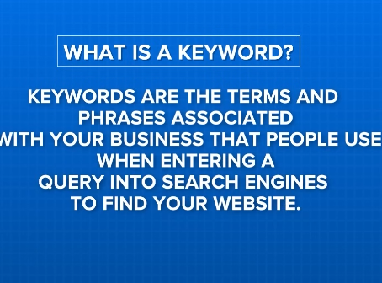

So keywords if we talk about SEO or business then keywords are those terms and phases that are associated with your website and related to your website and people who are searching it in search engine to find your website suppose your business is related to Digital Marketing and you give Digital marketing services

And you take keyword “Digital marketing institute in India” Now you think that this is related to my business or website then it become keyword for us but when you search it and you do research which we will see later that How you can use tools when you do research we see that nobody searching this keyword People are searching Digital marketing courses, digital Marketing training and nobody searching “Digital Marketing Institute in India” then it is not good keyword id not for us

So if you need to select a keyword then it should be related to Business or website. It should be related to your content and second thing that should be searched by the People Atleat 1 percent it was used in years then we call it your keyword . Suppose we go to Googe and type a keyword

“That is What is Startup” It is obcious we will see many results

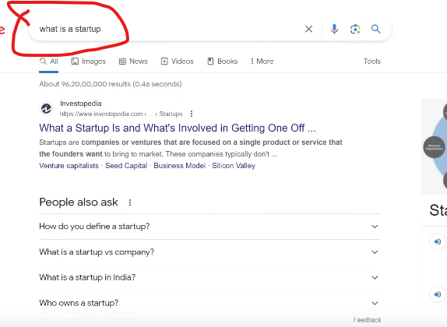

Npw you can see above marked is not four keyword but one keyword. Keyword could be a phrase

So the phrase “What is Startup” so it is a keyword

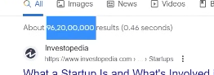

Now in this keyword you can see above highlighted results in 0.46 seconds

So google has given us result in Billions in below than one second

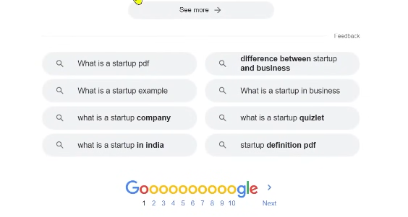

In bottom Google also give us some suggestion that these are the things that people are searching. If you want to use them also or you want to search them you an search it from here so the word we used for searching “what is startup” we call it keyword

1:40:55

Suppose we enter other keyword like wsCube It is Teacehrs company but it is a keyword also but by typing this people will find me and people are also searching for it

It can be anything you type a password. It is a keyword

Like we types “what is Startup” it is also a keyword but is this related to business. If yes then it is keyword for you otherwise if it is not related like apple is aa keyword and it has volume there(which will be told by the teacher later) but it is not related to our business that is related to anything No

Then it Is non keyword for us

**Lesson 20:-**

In this lesson we will learn about **Do Keyword really matter today**



Because many SEO expert believe that keyword play an important role without keyword you can not optimize your website according to the search engine on the other hand some expert say that this keyword does not play an important role If you are not using keyword then still your website will be ranked. So Today we will talk about this topic now and Teacher will share something or proofs so that for you it become clear that keywords are important then why it is

So first of all go back to the working of search engine we did understand its working isa divided into three parts

First is crawling

Second is Indexing

Third is Ranking

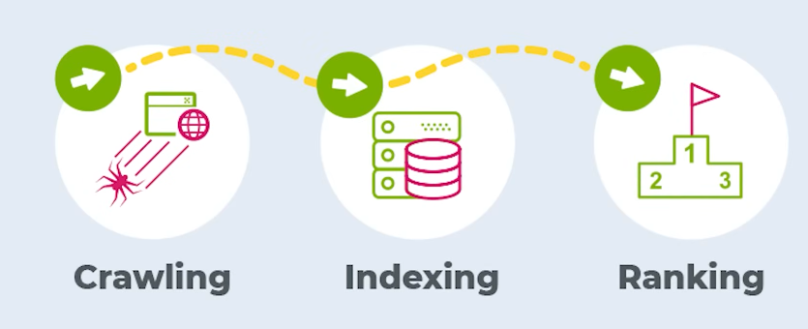

So after crawling if your page gets crawled and search engine crawler read them then comes the work of indexer to category

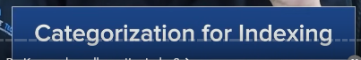

If in our website there is no business related , our product related , website related keyword then it would be really difficult to categorize our website and to put it in a particular indexing will be very difficult so that’s why keyword yes they are important but now the thing is will we take one keyword and put that in our website again and again now there is another phenomena which we call intent keyword



Often times you have not added the specific keyword in your website or instead you have used other intention related keyword(who knows) then still your website could be ranked or there could be good indexing it is also a possibility

For example you have business of Old cars

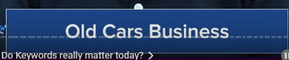

You purchase and **sell old cars** Lets suppose in your website you have not used old car keyword and on the place of that you have used **Second Hand Four Wheelers** or **Second Hand Cars**



Or you have use **used cars** or **used vehicle**



So in that case there are chances that your website could rank in old car because now google is focusing on Intention



Google is not target s particular keyword intead it is focusing on interntion Its example

Suppose Teacher open an incognito tab

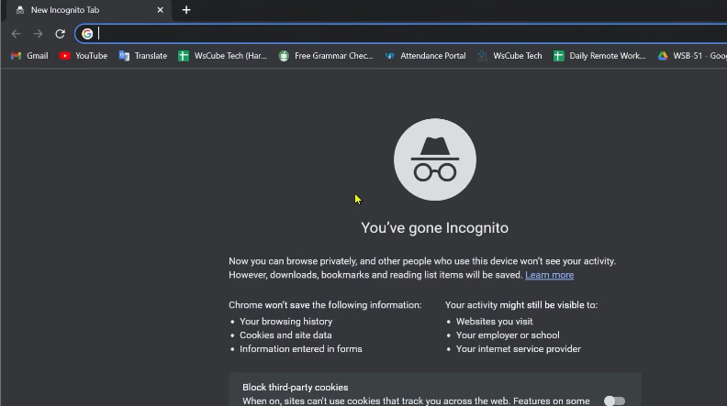

Here Teacher type the same example of old cars for sale

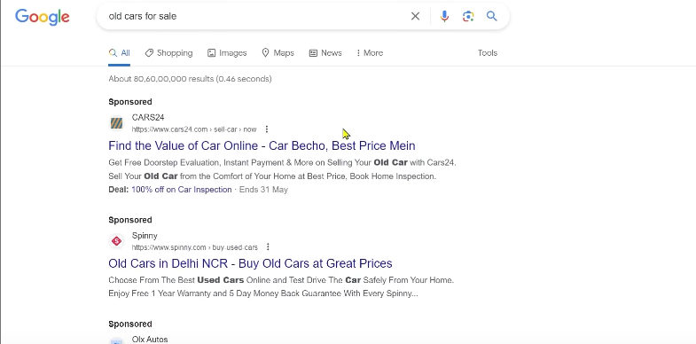

We type this keyword but in result we have result like old cars, used cars, second hand cars

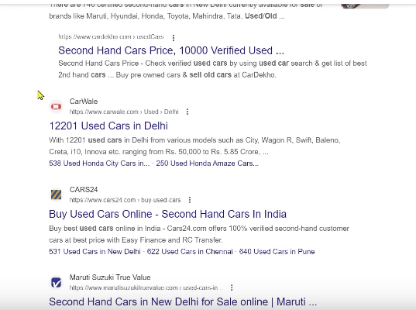

It means by not targeting the exact keyword

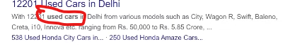

Even the highlighted text is marked above is used cards

So what google did . It understand the intention and according to that intention the best website we could see it

It does not matter that we have used old cars, second hand cars or used cars

Google just understand intention and according to that showed us result SO it is not necessary that you take one word and you are keep using it in our website. It is not a compulsion but you have to use keyword whether you use old cars or used cars or second hand course

But you have to use one of these keyword among them in the prominent part of the website otherwise our categorization will not be proper and you will not be able to tell that your website is of which category and of which particular index so that why keyword matters but in todays time intent keyword values has increased. Don’t get stuck only in one keyword . Try to add ,multiple keyword in your site

**Lesson 21:-**

In this lesson we will learn about in keyword digging we need to find keywords for our website SEO Now we will talk about major type of keyword



And the most important keyword is general and specific keyword

What is general and what is specific keyword and what to use in both of them.

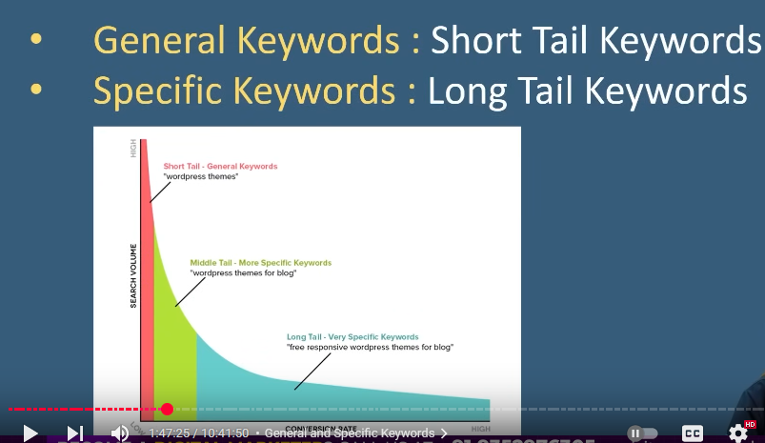

You must hears second name of general keyword as Short tail Keyword and specifc keyword as Long Tail keyword

Now we understand them

By short tail we mean that keyword which is very small in length here we take an example

Lets say we type a keyword Marketing

Noe here you tell what is the intention. Is our intention is of doing course, is my intention is of digital marketing. Is our intention is of understanding the meaning of marketing which s not clear

So what user want, his query , his keyword you could not know specifically that what type of result we should show then it means he is using general keyword that is short tail keyword

So “marketing” is a short tail keyword

On the other hand if any person type that marketing agencies in Delhi. If he types that keyword then what is happening here he want services he want agencies will see it who provide marketing agency and where, in Delhi

Here his query is specific

Or lets say he is typing what is marketing in Hindi. His query will become specific means it is specific keyword or we can say long tail keyword because mostly these specific keyword inside this there are more than two or three words are used that’s why it is called long tail keyword and the general keyword are comparatively small in size because they are not clearing the intention so that’s why we call it short tail keyword

Now Teacehr will show us major difference

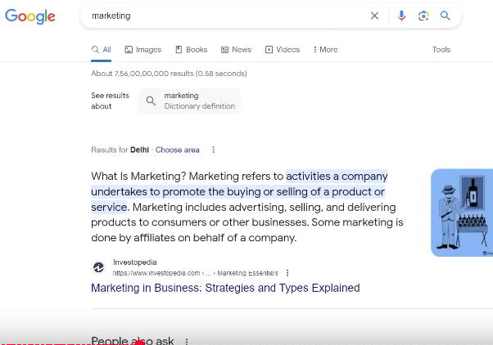

Suppose we type marketing in one tab

And then when we open another tab and type marketing agency in Delhi

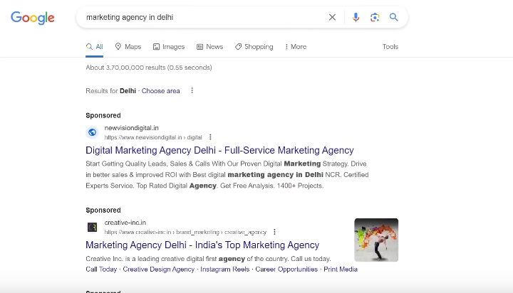

Now there are some normal difference

In marketing the result we are getting in “marketing” results

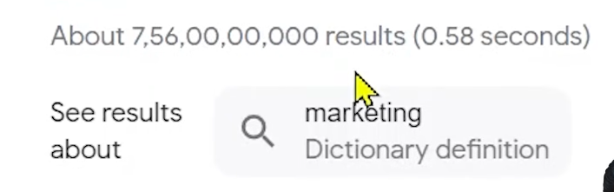

We are getting result in 10 digits

But if we type “marketing agency in Delhi”

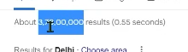

Here if we talk about 8 digits At least there is difference of 100 times means “marketing agency in Delhi” we are getting results is 100 times less than our short tail keyword that is general keyword

So here the thing is cleared that more the short your keyword will be or the more general keyword will be you have to bare the competition of your competition. Now competition mean if you want that your website should rank in this keyword then what are the other domain you have to fight with to rank first on Google means competition is too much much because we have to fight among all other result and make it first

If we make it specific then our competition get reduced there

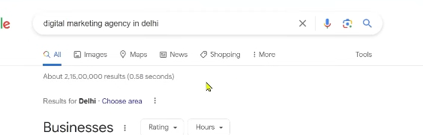

Now we make it more specific as shown above we add digital there that what type of marketing we want. Digital Marketing agency in Delhi

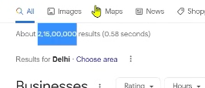

Now you can see here the competition is reduced more

In Marketing agency in Delhi we were getting 375 lakh results

And Digital marketing agency we are getting 215 lakh results

We can see the difference of almost 100 lakh

So competition is reduced there

Now is we make it more specific like we type “Digital marketing in Delhi for Ecommerce”

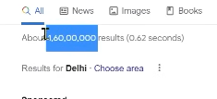

Now we see the result has reduced here meaning our competition is reduced here

The more specific your keyword will be your competition or domain to whom you have to fight will be reduced

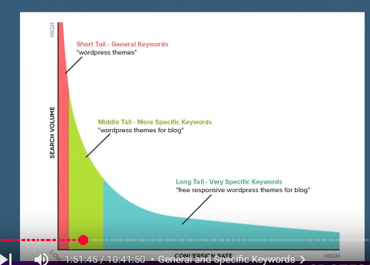

Now we take an example and above graph is given whenever there is our keyword

In x axis we have conversion rate and search volume is in y axis

1:51:50

When your keyword will become specific from general or we can say from short tail to long tail by that way our volume will become less because people searching for marketing are very huge in number if someone is searching digital marketing agency or course marketing word is coming everywhere so people who want to search marketing are more but the people who are searching for Digital marketing agency in Delhi for Ecommerce as your word start increasing or it will become more specific your volume will become more less you come to know by this graph but competition will be very less and when competition is less then our convergence rate increases

By convergence rate we mean the total people who wanted to become a potential customer and among them how many become that would be our convergence. Convergence will be increased because competition is less

So whenever we are taking short tail keyword you will get volume but by volume we mean on an average in a month how many people are searching this keyword we call it volume we will talk about it later So volume starts decreasing the more specific you will make your keyword and also competition will also decrease due to which our convergence rate increases.

Many people define long or short tail such that the keyword who has less than three words then we call it short tail. By long tail we mean where there are more than three words but no we don’t have any definition it is very unprofessional and also very naive definition You should give definition such that short tail keyword meaning those keyword which are done for general query. If someone search marketing we don’t know what will be the intention does he want marketing agency or marketing course or marketing services we do not know but specific keyword means long tail keyword Here user query is very specific you can guess what query you want and what page you want and so on.

Mostly for our website we use specific keyword. Why such that we will know about it later.

**Lesson 22:-**

In this lesson we will learn about **Navigational Keyword and should we use navigational keyword**



First of all we will understand what is Navigational Keyword and then should we use navigational keyword in our website or not So first we talk about what is navigational

Keyword so as the name suggests that keyword which for a particular website or particular destination is navigating means for example if a person search in google “women shoes amazon” If he search it then what are the intention. Does he want to purchase from your website or what does he want he want women shoes but he have specified it from which website that is amazon So when user clearly mention that what website he want to go on or from which website he should shop and from what website he should be shown on priority so we call it navigational keyword means where user direction is fix

Suppose someone searched cyber security course in wscube tech OK He search it on Google and lets say ws cube tech is coming on 7th position by the way it should not come in 7th position but lets assume so what he will do will he click on 1st link or will go to 7th link off course 99.9 percent chances are there he will search about wscube tech in the SERP and will click on it even when the website was shown in the 7th position because he clear in its intention that where does he want to go he wants to go to WS cube tech and what course he want to see that is Ws cube tech so this thing understood by google so whenever navigational keywords are searched then the website you see on 1st and second rank is the website you see which user have demanded.

Even in other keywords it was ranked in 100th position or 10th position it does not matter but if user clearly said that we want to go to that website then google will take him to that website

Lets take an example

Teacher search cyber security course wscube tech

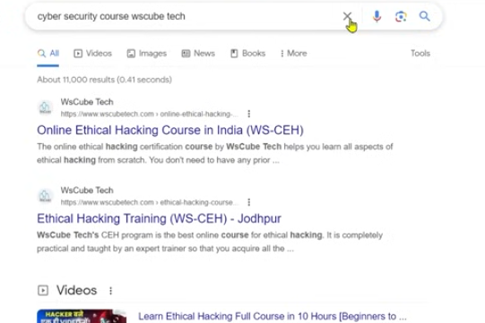

Even The top videos we see even you can see all the page are of ws cube tech then in such case where “cyber security course” if we talk about this keyword

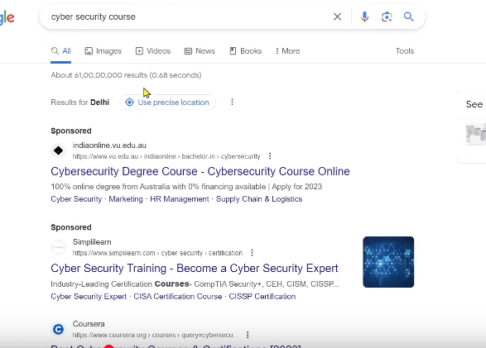

Then ws cube tech might not be ranked here in top 2 or 3 but as teacher enter “Cyber security course wscube tech” then Google knows he should go to this website Now question arises that in your website should you use navigational keyword of other company or brand name its answer is no. You should never use another company name even they are searching for it or not the volume may be good but still you should not use because it will not be benefitial for you because if a person in his query have mentioned amazon or wscube tech or xyz then google will only show him that was mentioned weather your website is at the top or at 100th it does not matter. So never use navigational keyword for your website then the question arises that we can use our name can we use it of course you should use it

You do it when you make website then you will enter your website name that is obvious you don’t have to do stuffing here but your come and there is no problem but another company name but you don’t have to use your company name in your website



It can happen that spam will be added on you

**Lesson 23:-**

In this lesson we will learn about **Keyword on the basis of intention**

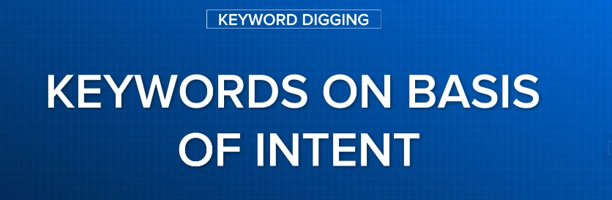

It means by what intention one person put a keyword in google. We will talk about those intention and with this we will understand that how many keyword are used for what website

By the way on the basis of intention there are four type of keyword

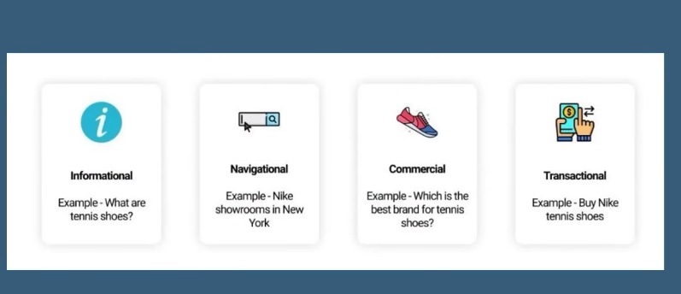

First is our **Informational Keyword**

Second is **Navigational Keyword**

Third is **Commercial Keyword**

Fourth is **Transactional Keyword**

So First is Information Keyword this is the keyword where the user for taking an information By information we did not mean related to business or products but for general information one person types a keyword then we call it **informational Keyword**

Now suppose someone searched what is the height of “Mount Everest” Chocolate recipe or some example is given there that is what are tennis shoes like

In these keyword he did not have to buy anything or he did not want any service , he did not want any training or course he is just doing a query so for informational cases mostly that get ranked that the website Google shows to the user are blogging website. So one thing is clear if you have a business website or is there any service based website or any ecommerce based then you will not be ranked there so that’s why for our commercial website

**Phase 13**

We will not touch our informational keyword By the way teacher will tell us how you can take the benefit of informational keyword because most of the times 60 percent query are related to informational keyword means used for information so later teacher will discuss that how you can use informational Keyword

Now second is **Navigational Keyword** that we talked about last lesson that is that keyword where the intention of the user is fix. User knows in which site he want to go and which location to go For example ‘Nike showroom, in New York’ first it is cleared that he want Nike Showrooms in New York. If there are other brand which are ranking but user has specified that to show him nike results Show nike showroom or nike website So nike website will be shown even your website get ranked in other keywords(who knows).

The third thing is **commercial keyword**

It is related to business but here one person is researching. He is trying o find out that what shoes he should take what are better. Comparison in two brands. These are commercial keyword

Now comes **Transactional Keyword** Here user knows that he want some particular product and he want to buy it then he will type such keyword by there is no huge difference between them . Noth type of keyword are related to business or product or service related but you can differentiate them by that in transactional keyword there are words like buy, get, book, visit such type of words are used dur to which we know it is a transactional keyword so if you have business or service based website then commercial and transactional keyword are for you but if you have blogging website then informational keyword is for you

Lets go to Google and look an example where teacher typed “What is IPL” then you will see that whatever result you see there is a blogging or informational website

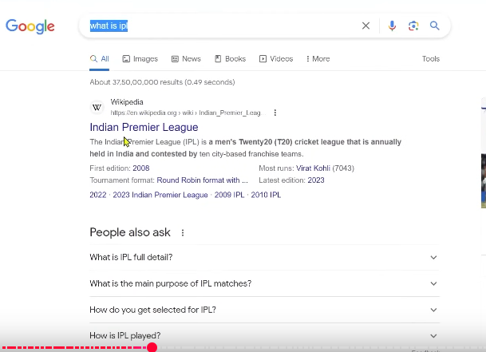

Like Wikipedia, Britanicca, Quora . Here we get results here. It is an informational keyword

02:02:15

These are the website through which we get the information but what type of keyword id this it is informational keyword and in such cases our blogging website will be ranked because it is an informational keyword but if we type IPL Wikipedia then you will see ipl related pages you will see here so it is a navigation keyword as shown below

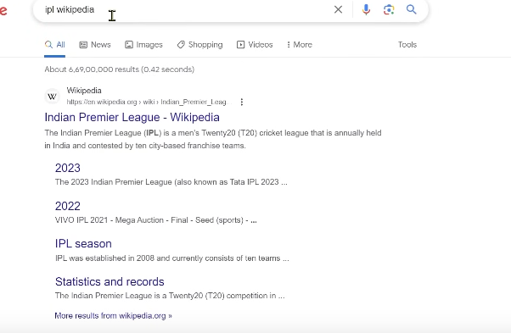

But if we type where to book ipl ticket then you can see

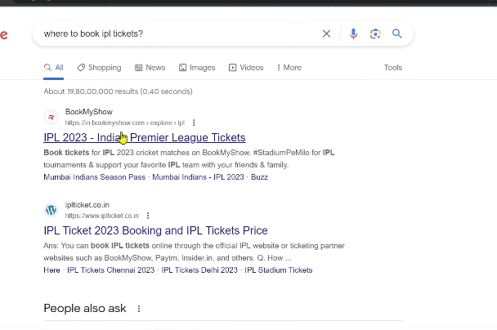

Here you could see the website which are selling ipl website

You will see onlyu business or service website here

If we type buy ticket online then we will also see business website here

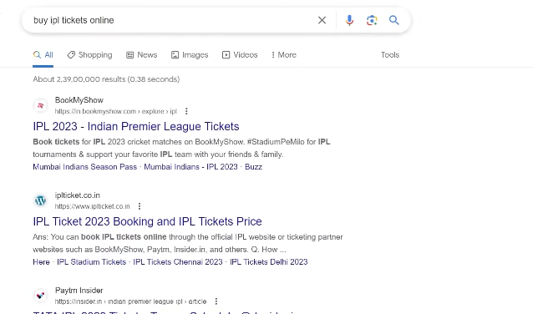

So in commercial and transactional keyword you can see business website but in information you can see blogging website and in navigation you will see the website whose name is entered in the query

So You must have understood the difference between all intent based keywords

There are other type of keyword the we need to understand that is LSI keyword

It means latent semantic Indexing keyword mean those keyword which when get added with main keyword and we add some term that by which we can make our search engine understood that our content is related to what

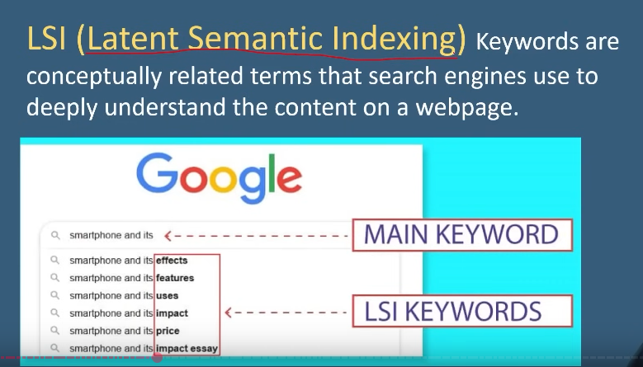

Suppose we type IPL ticket then with that what you can add that is IPL ticket prices if you have mentioned in your website that is IPL ticket prices then google will know that this particular website is for the ipl ticket prices and has written blog about it

Lets suppose we type that ipl ticket website it mean those website that is selling ipl ticket so it is an LSI keyword means those keyword which is related to our main keyword and the modified term of our main keyword and with that they tell the content in depth that is what it is our content so we should alos use lsi keyword you don’t have to use short tail or loing tail keyword but you have toi specify somewhat and use lsi keyword by the way we also call synonymns as lsi suppose a word and it has synonym suppose in place of ticket we can use “pass” word So pass is a lsi keyword

**Lesson 24:-**

In this lesson we will learn about informational keyword and how to use for business website

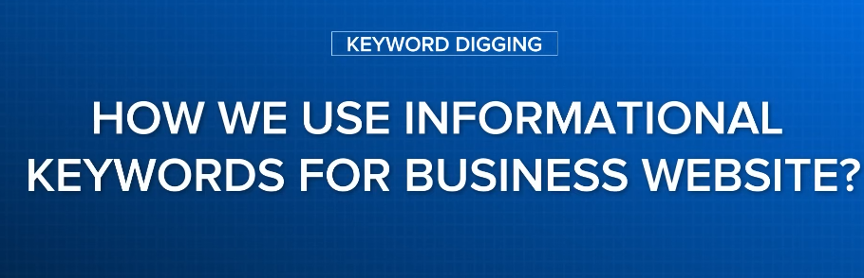

Because information keyword are among the most search thing in search engine

This will definitlely come to your mind that why not use it for our website and use it to grow our business So today we will talk about it that by the way informational keyword is used in blogging website but how to use it for our website Here we need to play smartly

We call this technique web 2.0 you don’t have to confuse with it because we will talk about this topic in off page later but here understand lets see a case study about what teaceher is talking about

Now Teacher opens her website



It is a business website and service you give there are listed here whatever sourese you want tp purchase you purchase there

We know that we can only us transactional keyword related to business but in our niche or any niche you will see many informational keyword

So what teacher do teacher created a more menu

If you hover over it then in submenu yiu can see below

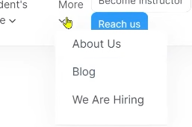

Now you can click on blog When you see there

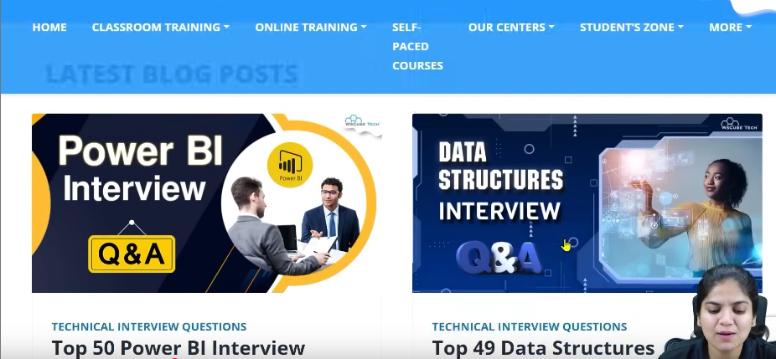

You can see many blogs so we drive our informational keyword in our blog page

And in our every blog if you open any blog of Teacher website you will see a many links

That is in each blog that is our main website or business website there are many links related to it

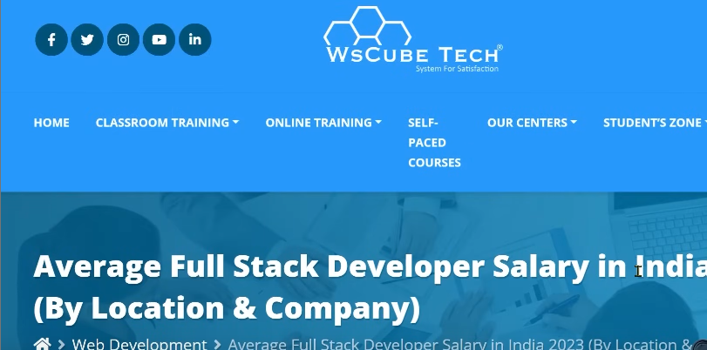

Now above is a blog Now whenever there is a person comes and read this blog

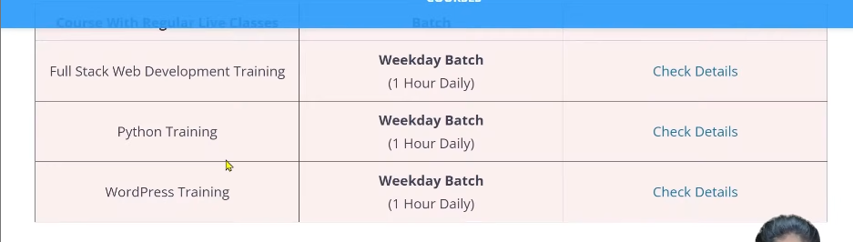

Now you see there are many links that are directing you to the teachers to main website page or landing where we want out user and enroll for our batch we have used links there

No we have targeted informational keyword in our blog part and here we are diverting our business home or landing page See this is a good way to use informational keyword for your business .First of all related to your niche or fields the type of services you are giving grab some informational keyword and on that informational keyword and write blogs on them

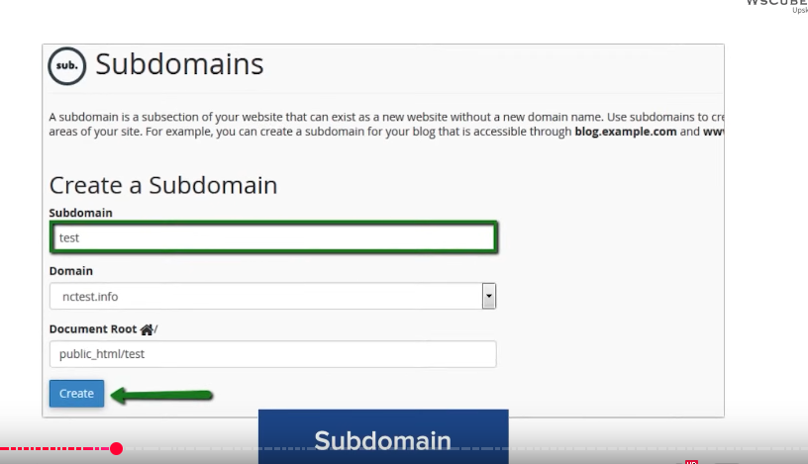

Whether you can create sub domain

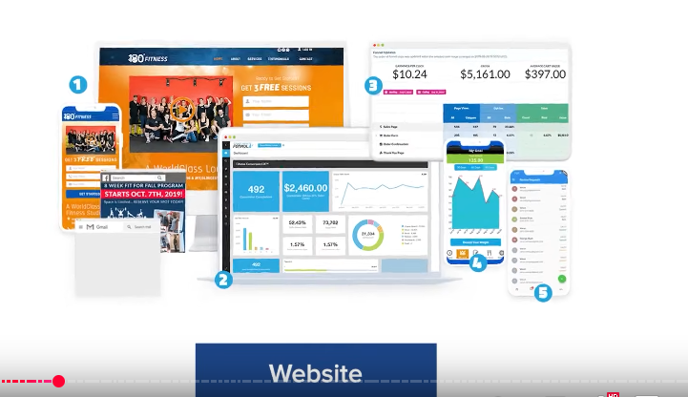

Or new website or you can create pages also by using keyword you write blogs on them and on those blogs target Informational keyword when people will come in your blogs and through your informational keyword then it can happen that many people are interested in business or product and from there they can purchase your products for example

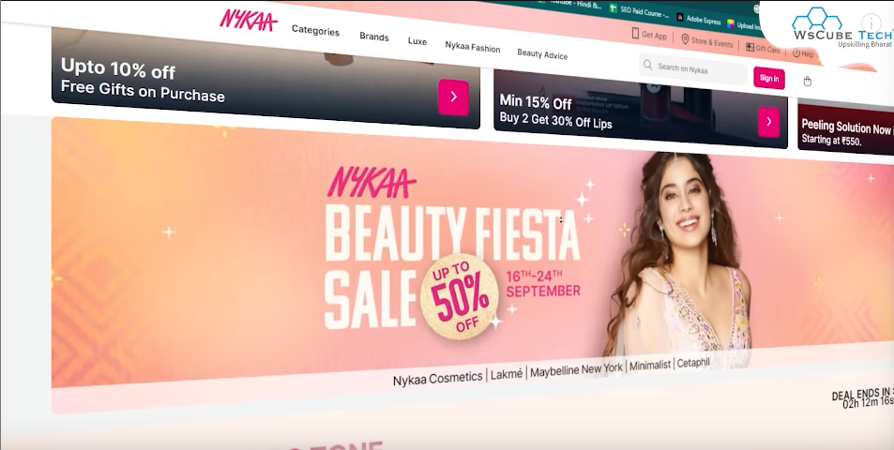

There is makeup online shopping site This is a common sense thing here you will use transactional or commercial keyword

Then you can use informational keyword like there are makeup tutorials or reviews some difference in our product you can create such blogs and when people come there then you can add internal links

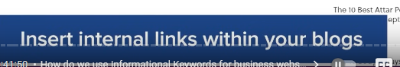

Of product or category pages

So by this way informational keyword which are the most used keyword in google you can use it in your business

**Phase 14**

**Lesson 25:-**

In this lesson we will learn about **Singular and Plural keywords**

Is there any difference in them

For example if you are getting keywords like Car Manufacturer and Car Manufacturers

Do we need to treat them differently means if we are getting car manufacturers then do we have to use it Do we have to use this keyword or not we need to understand it slightly

SO to understand it we do a small experiment in Google then we can understand that whether singular or plural keyword create difference or not

For example teacher type a keyword

Books online in India

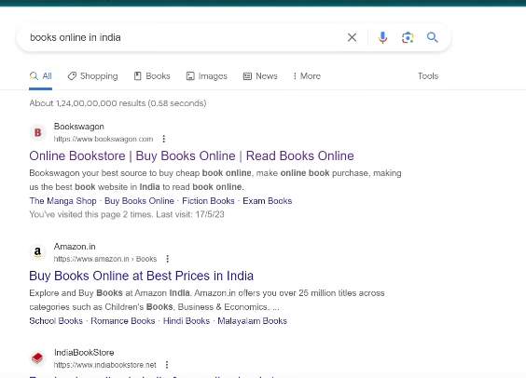

And in another tab we types book online in India

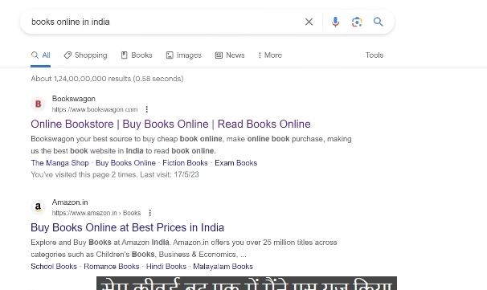

Both are same keyword but in one we use s but in another s is not used

Now see the notice the difference in result

Result in Book online in India is below



And Result in Books online in India

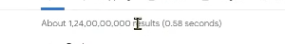

Now you will notice that in “books online in India” half competition is reduced

So when we typed books then competition is almost half as the result gets halfed

Apart from it if we talk about ranking then the first thing that get ranked in Books

is Bookswagon, second is Amazon.in

Third is India Bookstore

And fourth is Flipkart

And in book

Bookswagon again also rank topped here

Second is India Book store

And Amazon is in third position which was second in position

And fourth is SapnaOnline which was in 5th position is in fourth position

If you compare it whole almost all page are same but just sequencing has changed and aprt from ti competition has been reduced

We have noticed one thing is that when we wrote with s and non s then difference comes so that’s why we cannot deny that we ca use singular in place of plural or vice versa

If in keyword research time we are getting good volume in books keyword then use books. You don’t have to use book there. because if you use book keyword then you can get comparatively separate result

So this is a small difference. Hardly it matters but one effect can make our ranking from one to 100 or from 100 to 1.

So we will take these small things then we can secure our first ranking in first page but the other thing the teacher told that keyword are not the only factor but there are also other factors are considered but this is also a factor so by including small small factor our website ranking will increase.

Teacher take another example

Now the teacher type

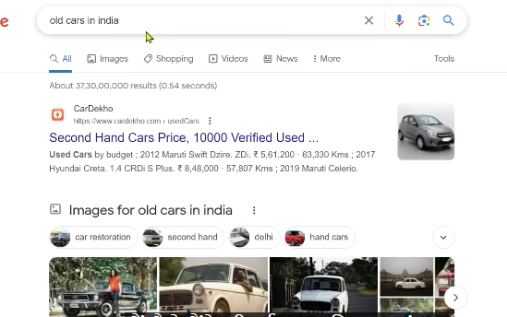

**Old cars in India**

And then in another tab we type

**Old car in India**

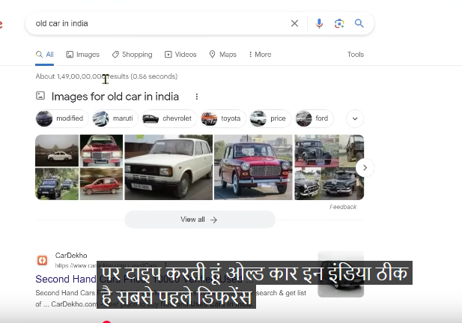

Now we will see the difference

In **old car in India** you see result



We are getting result in 10 digit number

But in **old cars in India**

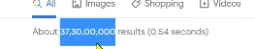

We have only 9 digits

We are getting 10 times difference

So we are getting less competition in cars but with it if we talk about ranking then ranking has also been shuffled

2:13:45

Like we saw in precious examples

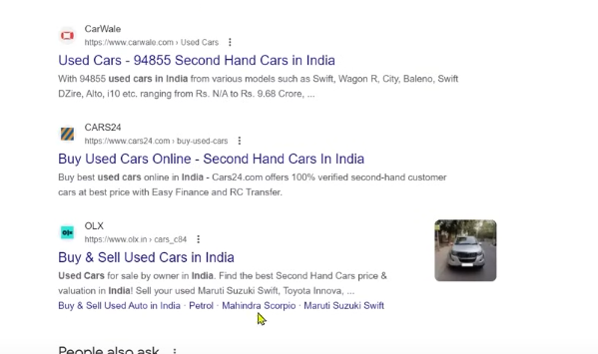

If we talk about ranking in old cars

CarWale

Car24

OLX

The olx isa in third position which wa not there previously

The carwale was in third posirion but now in second position

So the ranking is shuffled that means singular or plural keyword somewhat matters

So Where you want to use singular use singular where you want o use plural user plural when you do keyword research

Then when we do keyword research then you will understand it properly

**Lesson 26:-**

In this lesson we will learn about **Brainstorming for Keyword**

Whenever you are doing keyword research then first step will be **brainstorming**



Use your brain and find out that what are those keyword that you think people might be searching by the way we will talk about those keyword which are search by people not what we think but you have to start from your mind you need to think that for a particular business or web page or blog what people are searching for it So lets see How to do brainstorming

Whenever you want to do brainstorming then you need to keep these things in mind

First you have to make category for your keyword for example at first is our root keyword lets take an example

That is Interior Design in Bangalore

Suppose one client comes and he says that it is our root keyword and he is an interior designer and he serves in it and he serves in Bangalore so do SEO

So first of all we have to do keyword research

We need to build categories like it could be Home ID , Kitchen ID, Office ID

Meaning we are categorizing our main root keyword

Whenever you are doing analysis in mind then bring categories here.

Second thing is you can find synonyms which we can call lsi keyword Suppose it is an interior design we can call it interior decorators, interior designing company , interior designer

So these are some synonyms

Apart from it you could add superlatives because people will normally not search interior designer for example best interior designer, top interior designer in Bangalore , Luxury interior designer in Bangalore and Affordable interior designer in Bangalore so keep these keyword combination in mind

We will talk about it later that what keyword to choose but you have to find some possible keyword to choose from what base you will give to tools(who knows)

So first step you need to do is brainstorming

For brainstorming we take excel and we will use excel for keyword research

So in our excel file that opened

Write a Headline named Keywords first of all you need to add root keyword

So after writing Keyword heading we write root keyword below it

And then below it we go to categories

Like Kitchen Interior designer in Bangalore

And then comes superlative keyword as shown below

The combination forming in our mind

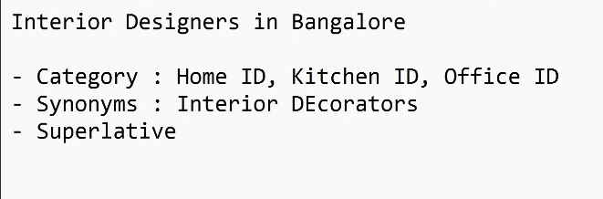

By using above things we will create 10-15 keyword by our mind We did not use any tool , or Google use we just have to do brainstorming and generate some keyword what we need to do them will be told by the teacher but for now we need to do brainstorming

Now teacher add some more keyword in the keyword column in the excel

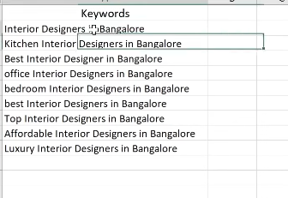

As you can see teacher has done some brainstorming and added some superlatives apart from it we have added some categories So our brainstorming have happened. This brainstorming is according to you think that people search it but it is not necessary that whatever you are thinking are people are searching it Now we use our tools of keyword research we use in upcoming lessons and by using them we will use these brainstorm keyword we will generate new keyword Apart from it for brainstorming you can use Google search engine result page. For that we will go to Google and we use the root keyword and search it

After entering it

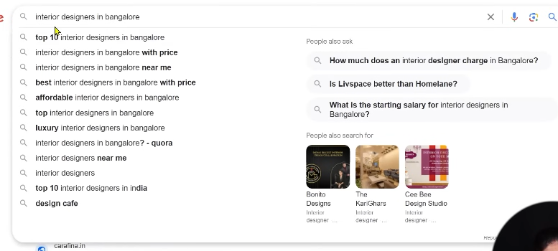

When you put the cursor in the search field then you will see many recommendation as shown above so from here you can take ideas . the interesting that the teacher find is

Second option will be lsi keyword

Fourth and sixth So you can copy them and add to the excel

So these are those that are founded by brainstorming

There is another way to do brainstorming it is a hack in search engine

You can come to the first word of keyword and then add _<space>

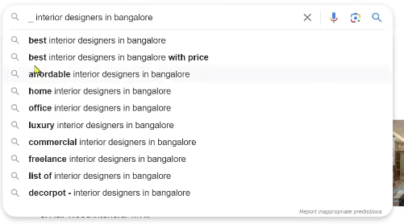

Now you can see that the front superlative or adjective which people are searched are also there

You can see commercial wala keyword in 7th this is new keyword

**Phase 15**

you can add it to your excel file so whatever keyword you think that you have not even search it you can add it to the sheet

Now this underscore technique special fact is you can use it any where

You can use it in middle like in interior design in Bangalore you replace design with _

Now we have used underscore technique between the keyword

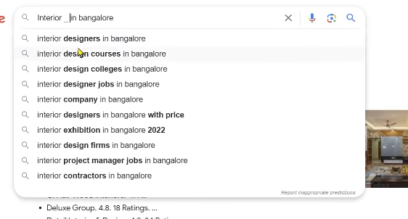

Now you can see all the keyword are opened

Now second is not related to website or business

But 8th option this is intrior design firm in Bangalore

We get another keyword we can also add It to excel file

Whenever you find new keyword add It to excel

When you go to bottom then you can see the suggestion here as shown below

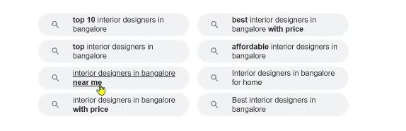

You can copy them and paste it in your excel file if you find any keyword is interesting so byb this way you can do your brainstorming but as teacher said these are those keyword which you think people are searching Now we use tools and see what people are actually searching

**Lesson 27:-**

In this lesson we will learn about **Basic that keywords research we are doing what are the important to keep in mind**

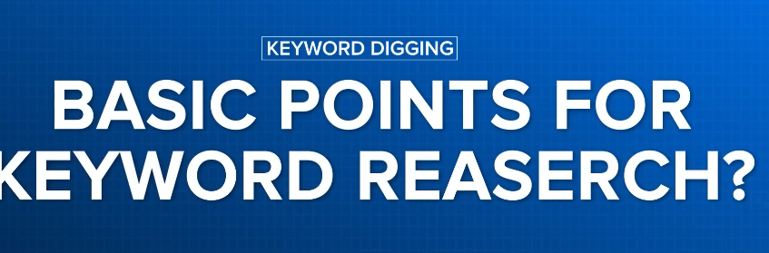

So first thing to do is Keyword research



By keyword research we mean those website or webpage find those keyword that we want our website rank

When we try to find these things Its not an easy talk. There are many things to keep in mind and we will do a lot of practise in this course so that you can excel in keyword research game.

Now teacher summarise the basic point for keyword search will be summarised in four points



What is volume we understand it and what are the other names of it you can see it



By volume we mean average monthly suppose teacher bring a keyword that is interior designer keyword so this keyword on an average in one month how many people ar searching in Google

Suppose in one month someone search it 1000 times in one month there were 2000 searches for this exact keyword apart from this in one month it become 500 and then 100 in another month so by taking 1 year data divide by 12 we find the average month data



So we call these volume or average monthly traffic if you see nay of them then don’t get confused whenever we are doing keyword research then you need to consider whatever keyword you are to add to your website it has good volume or not so when we do keyword research or keyword choose our target is that we get more volume keyword



Second thing is competition Many times you see competition word Many times you see a word **SEO difficulty**



And many times you will see **Keyword difficulty**



All of these means competition

Now by competition we mean in any keyword to rank on it How many of other domain you had to fight with mean how much competition is there if you want to rank there So we always want that whatever keyword we are choosing there should be less competition

So here is a thumb rule that whenever you search keyword then volume should be high competitively as compared to other keyword and competition should be low



2:23:48